**Curriculum Vitae**

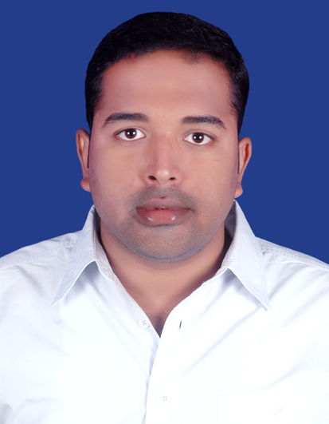

Please affix a

Passport size

photo here

# Name : LAXMIKANTA PANDA

**Address : Bita-501,Versa Riveria apartment,**

**Tankapani road ,Bhubaneswar -752100.**

**Mobile No :** 9439300200

# E-mail :laxmikant_panda@yahoo.co.in

**Academic Qualifications:**

|  |  |  |  |  |  |
| --- | --- | --- | --- | --- | --- |
| **Degree / Certificate** | Qualification | Institute | Board /University | **Year of passing** | **Aggregate % / CGPA** |
| Graduation | B-TECH | KONARK INSTITUTE OF SCIENCE AND TECHNOLOGY | BPUT | 2011-2012 | **6.57** |
| 12th | +2 SCIENCE | BUXI JAGABANDHU ENGLISH MEDIUM SCHOOL | CBSE | 2007 | **56** |
| 10th | MATRICULATION | BUXI JAGABANDHU ENGLISH MEDIUM SCHOOL | CBSE | 2005 | **78** |

**SPECIALISATION IN ENGINEERING- ELECTRICAL ENGINEERING.**

**Trainings / Projects Undertaken:**

|  |  |  |
| --- | --- | --- |
| **Name of Institute / Organization** | **Project Title** | **Duration** |
| * KONARK INSTITUTE OF SCIENCE AND TECHNOLOGY. | AUTOMATED SOLAR TRACKING SYSTEM. | 3 Months |
| * SANJEEVANI NURSING HOME. | HOSPITAL AUTOMATION SYSTEM. | 1 months |

**SUMMER TRAINING: HIRAKUD POWER PLANT.**

**Additional Qualification / Achievements / Certifications:**

* Third prize in inter school “MAGGIE QUIZ” contest.
* Co-ordinator in organizing -BLOOD DONATION CAMP’S
* President of the core committee in college annual function “UTOPIA 2011”.
* Captain of college cricket team.

**Job Objective**:

To obtain the right learning curve through my experiences and to use them in real time scenarios and work on their improvement, so as to excel both professionally and personally. Keep excelling by meeting objectives and goals while upholding all the core values of the organization.

**WORK EXPERIENCE:**

**COMPANY:FALCON REAL ESTATE PVT LTD.**

**TENURE:** August 2011-April 2013

**POSITION:** Sales manager

**COMPANY: ICICI PRUDENTIAL LIFE INSURANCE COMPANY LTD.**

**TENURE**: April 2013 – November 2013

**POSITION**: Development Manager

**COMPANY: NEXTRONICS PVT LTD**

**TENURE**: November 2013-TILL DATE

**POSITION**: Development Manager

**ROLES AND RESPONSIBILITIES:**

Acting as One Point Contact for a customer for his entire operational activities and maintained customer centric operations to ensure customer satisfaction by achieving delivery & service quality norms.

**OPERATIONS:**

* Ensure KYC norms are adhering to all point of time.
* Submission of daily schedule indicating the Third party sales done.
* Ensure certification of documentation required for opening and maintaining customer accounts.

#### CUSTOMER SERVICES:

* Ensure quality customer service is delivered and recording complaints as per the specified process.
* Resolving all complaints received (self, branch, other units) within the stipulated TAT.
* Promoting all direct banking channels and ensuring that the customer is utilizing the same.

**Hobbies:**

* Travelling
* Music

**Personal Details:**

**Date of Birth :** 18 Frebruary, 1990

**Gender** **:** Male

**Languages Known :** English, Hindi,Odia.

**Declaration: I do hereby confirm that the above information is true to the best of my knowledge and belief.**